Public Community Profile

Users  - Primary  - Community manager  - Secondary  - Visitors | Phase 1
Intended Outcome
- Organizers create their community profile as they want to introduce their communities to outsiders and prospective members.
- Visitors interact with community they select as they are served with community profile
Links
- …
- …
- …
- …
- …

Introduction
One of the community organizers we invited to try Kolavo ended up leaving after registration and saying that he wanted to see communities in it before creating his own. This seems he did not have the motivation of creating his community profile because he did not know what it would look like. Therefore, we want to motivate community organizers to create their community profiles by introducing communities through profiles to the public.
In addition to that, people who are invited to try Kolavo directly leave as soon as they see the current default page: login page. It seems they did not have the appetite to browse around since there is no interesting information they can find. Therefore, we want to increase their attention to the Kolavo app by sharing community profiles.

Product Requirement

Public Community Profile
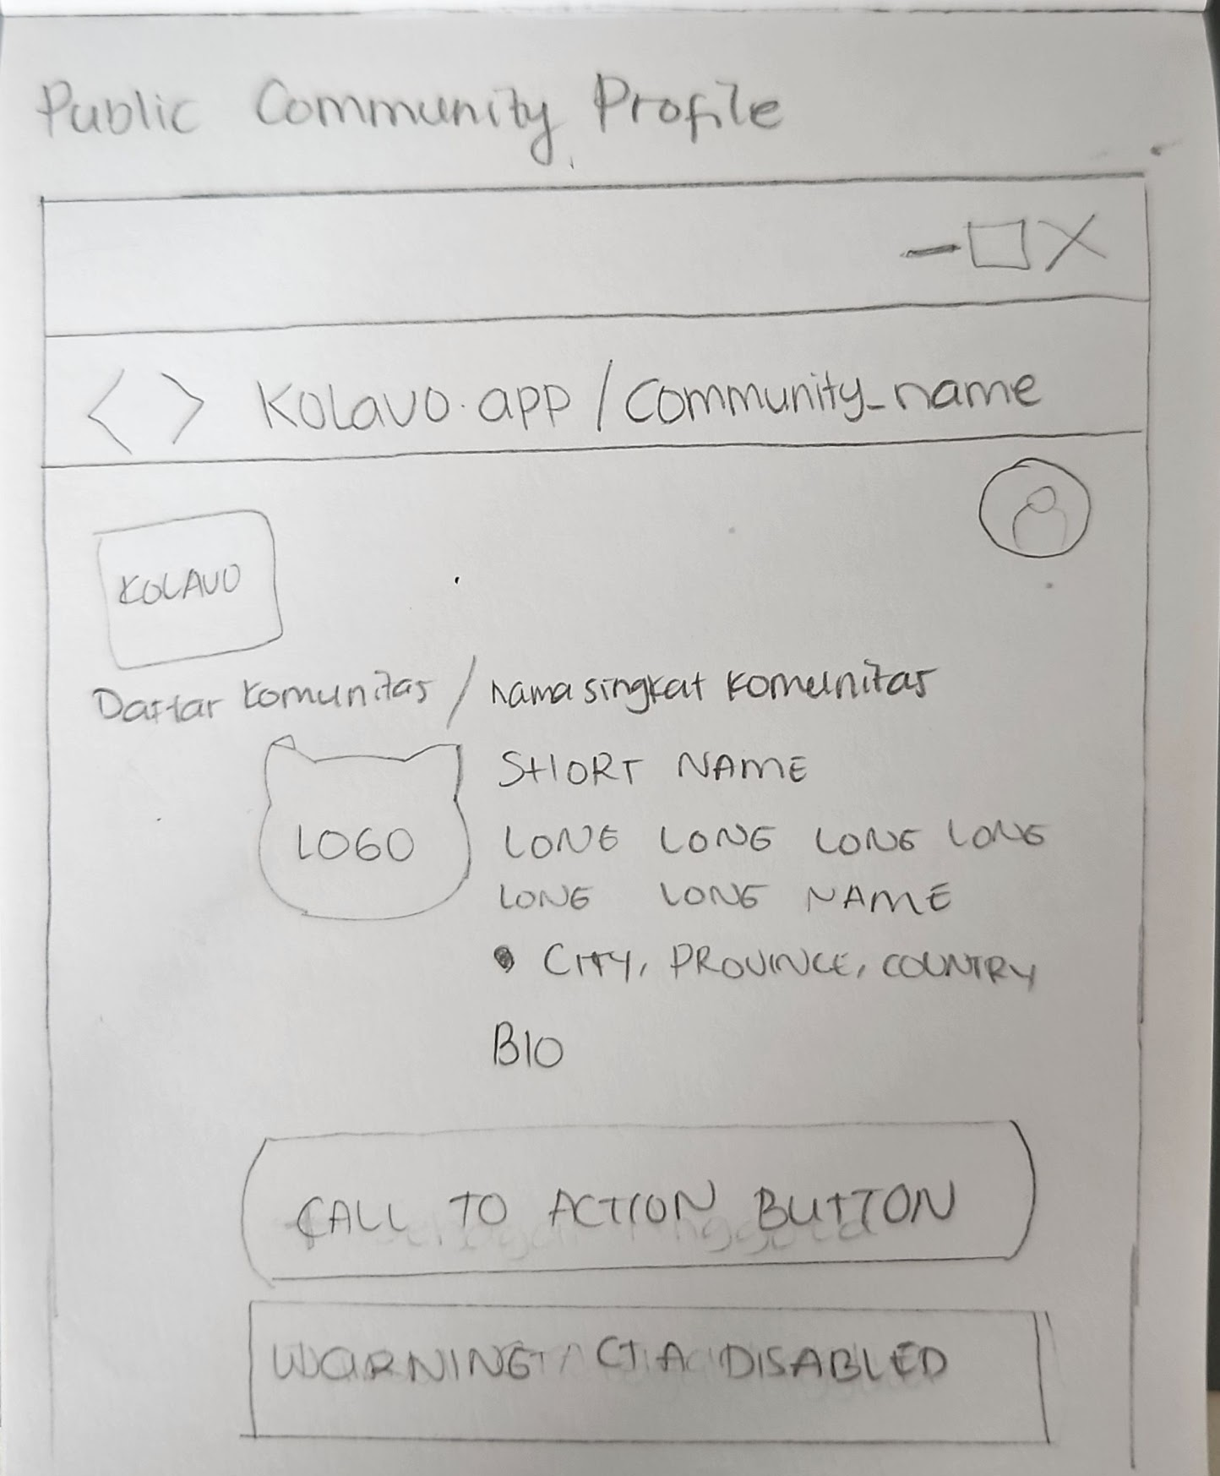
No | User story | Scope | Acceptance Criteria
1 | As community managers, I want to know what community information will be further shown, so I can prepare the data.. | Community profile visible to non registered users | - Community profile is shown after clicking it in the homepage
1 |  | Community profile is shown in community page | - Community profile is the first section in community page  - Community page background color theme is adjusted as set by community manager  - Information including:  - Logo  - Shortname  - Long name  - Domicile  - Bio
2 | As community managers, I want to know how Kolavo could help us collect our member data, so we can decide whether or not it is helpful. | Call to action is part of community profile | - CTA is close to community profile  - User need to login to join community  - Different state show on CTA based on membership status
3 | As community organizers, I want to see other community profiles listed in community directory | Way to return to community list | - In pc, outside community profile area, show clickable breadcrumbs  - Start with community list then slash community short name  - For mobile, give back button to give sign

Design Requirement

Community Profile Header Layout
Design Intent | The logo and profile information should feel like one cohesive identity block, similar to a profile layout rather than a document header.
Content / Copy | Includes community logo, long name, location, bio, and primary CTA.
Visual Requirement | Arrange logo and profile text in a horizontally balanced layout within the centered container. The spacing between logo and text should feel intentional and visually proportional.
Interaction Behavior | Static by default. Layout should maintain balance when profile copy becomes slightly longer or shorter.
Acceptance Criteria | - On desktop, the logo and profile information appear visually grouped and balanced.  - The profile does not appear left-heavy or disconnected.  - The CTA remains aligned within the same visual profile block.

Background Color
Design Intent | To increase related community nuance
Content / Copy | -
Visual Requirement | - Use chosen color themed  - 5% transparent
Interaction Behavior | -
Acceptance Criteria | - Background community page uses the selected community theme color.  - Background color is displayed with 5% opacity or transparency.  - Background color is applied consistently across the intended background area.  - Background color does not reduce readability of text and other UI elements.

Breadcrumbs
Design Intent | Ease users access homepage containing list of communities from community page
Content / Copy | Daftar Komunitas / [community short name]
Visual Requirement | - The placement is left align as Kolavo logo  - The color of clickable word is following community theme color  - The color of / and community short name is default #342621 (dark brown)  - Use Body S style which are:  - Font Family: Poppins, sans-serif  - Font Weight: 400  - Font Size: 14px  - Line Height: 21px  - Letter Spacing: 0px  - Text Color: #342621 (Dark Brown)  - Text Align: Left
Interaction Behavior | When click Daftar Komunitas, redirect to homepage/community list
Acceptance Criteria | - Breadcrumbs show Daftar Komunitas / [community short name].  - Breadcrumbs are left-aligned in line with the Kolavo logo.  - Daftar Komunitas is shown in the selected community theme color.  - / and [community short name] are shown in #342621.  - Breadcrumbs use Poppins, font weight 400, font size 14px, line height 21px, letter spacing 0px.  - Clicking Daftar Komunitas redirects the user to the homepage or community list page.  - [community short name] is displayed as plain text and is not clickable.

Back Button
Design Intent | Ease users notice what community page they see and how to go back to community list when accessing from mobile phone
Content / Copy | Left arrow sign and community short name
Visual Requirement | - No Kolavo logo  - Left arrow sign is at the top left  - Community short name is at the top right  - Both are at the same row and use Body S style which are:  - Font Family: Poppins, sans-serif  - Font Weight: 400  - Font Size: 14px  - Line Height: 21px  - Letter Spacing: 0px  - Text Color: #342621 (Dark Brown)
Interaction Behavior | - Back to community list when tapping back button  - Nothing happen when tapping short community name
Acceptance Criteria | - Back button appears on mobile view only.  - Kolavo logo is not shown when the back button header is used.  - A left arrow icon is displayed on the top left.  - [community short name] is displayed on the same row.  - The left arrow icon and [community short name] use Poppins, font weight 400, font size 14px, line height 21px, letter spacing 0px, and text color #342621.  - Tapping the left arrow redirects the user to the homepage or community list page.  - Tapping [community short name] does not trigger any action.

Community Logo
Design Intent | Ease users to identify community by visual
Content / Copy | Picture of community logo
Visual Requirement | - Place in community profile section  - Left align but indent a bit more than left arrow  - When logo is not uploaded, use first initial letter in white with color theme for background
Interaction Behavior | Nothing happen
Acceptance Criteria | - Community logo is shown in the community profile section.  - Community logo is aligned to the left and slightly more indented than the back arrow.  - If a logo has been uploaded, the uploaded image is displayed.  - If no logo has been uploaded, a fallback avatar is shown using the first initial letter of the community name.  - The fallback avatar uses white text on the selected community theme color background.  - Community logo is static and not clickable.

Community Long Name
Design Intent | Ease users to identify community long name
Content / Copy | Community long name input in community page creation form
Visual Requirement | - Placed next to community logo  - Use L style which are:  - Font Family: Poppins, sans-serif  - Font Weight: 500  - Font Size: 18px  - Line Height: 24px  - Letter Spacing: -1px  - Text Color: #342621 (Dark Brown)  - Text align: Left  - Capitalization: Title Case
Interaction Behavior | -
Acceptance Criteria | - Community long name is displayed using the value entered in the community page creation form.  - Community long name is placed next to the community logo.  - Community long name uses Poppins, font weight 500, font size 20px, line height 24px, letter spacing -1px, and text color #342621.  - Community long name is left-aligned.  - Community long name is displayed in Title Case.

Community Domicile
Design Intent | To ease user confirming the community they intend to see
Content / Copy | [City Name], [Province Name], [Country Name]
Visual Requirement | - Placed next to community logo under community long name  - Give location icon  - Use Body S style which are:  - Font Family: Poppins, sans-serif  - Font Weight: 400  - Font Size: 14px  - Line Height: 24px  - Letter Spacing: 0px  - Text Color: #342621 (Dark Brown)  - Text align: Left  - Capitalization: Title Case
Interaction Behavior | -
Acceptance Criteria | - Community domicile is displayed in the format [City Name], [Province Name], [Country Name].  - Community domicile is placed next to the community logo under the community long name.  - A location icon is shown before the domicile text.  - Community domicile uses Poppins, font weight 400, font size 16px, line height 24px, letter spacing 0px, and text color #342621.  - Community domicile is left-aligned.  - Community domicile is displayed in Title Case.

Bio
Design Intent | To allow community managers say anything they want
Content / Copy | [Bio]
Visual Requirement | - On desktop, the bio is placed within the community profile information area below the community domicile and aligned with the text block.  - On mobile, the bio is placed below the logo-and-identity section as a separate full-width text block.  - Use Body S style which are:  - Font Family: Poppins, sans-serif  - Font Weight: 400  - Font Size: 14px  - Line Height: 24px  - Letter Spacing: 0px  - Text Color: #342621 (Dark Brown)  - Text align: Left  - Allow to use emoji  - Maximum 150 characters
Interaction Behavior | -
Acceptance Criteria | - Community bio is displayed using the saved bio content.  - Bio is placed next to the community logo under the community domicile.  - Bio uses Poppins, font weight 400, font size 16px, line height 24px, letter spacing 0px, and text color #342621.  - Bio is left-aligned.  - Bio supports emoji rendering.  - Bio is limited to a maximum of 150 characters.  - If no bio is provided, the bio area is hidden or shown empty based on product decision.

Call to Action Button
Design Intent | - Invite members to join  - Ease users to notice their membership status related to the community
Content / Copy | Depending on condition:  - Not member + membership not set up: Belum Bisa Gabung  - Not member: Gabung  - Registered but not approved yet: Menunggu Persetujuan  - Member: Sudah Anggota
Visual Requirement | Depending on their role:  - Not member + membership setup:  - Font Family: Poppins, sans-serif  - Font Weight: 500 (Medium)  - Background Color: Chosen theme color  - Text Color: #FFFFFF (White)  - Padding: 24px horizontal (px-6), 12px vertical (py-3)  - Border Radius: 8px (rounded-lg)  - Not Member + membership not setup, Registered but not approved yet, and Member:  - Font Family: Poppins, sans-serif  - Font Weight: 500 (Medium)  - Background Color: #6b7280 (Dark grey)  - Text Color: #FFFFFF (White)  - Padding: 24px horizontal (px-6), 12px vertical (py-3)  - Border Radius: 8px (rounded-lg)
Interaction Behavior | - Not member + membership setup:  - Hover Effect: Box shadow 2px 2px 8px rgba(0, 0, 0, 0.15)  - Transition: Shadow transition  - Opens membership registration form when clicked  - Not Member + membership not setup, Registered but not approved yet and Member:  - Hover Effect: Box shadow 2px 2px 8px rgba(0, 0, 0, 0.15)  - Shadow color: chosen theme color  - Transition: Shadow transition  - Nothing happen when clicked
Acceptance Criteria | - CTA button label changes based on user role and membership setup status.  - For users who are not members and membership is set up, CTA shows Gabung.  - For users who are not members and membership is not set up, CTA shows Belum Bisa Gabung.  - For users who are already members, CTA shows Sudah Anggota.  - CTA uses Poppins with font weight 500.  - CTA uses 24px horizontal padding, 12px vertical padding, and 8px border radius.  - Gabung button uses the selected community theme color as background and white text.  - Belum Bisa Gabung, Sudah Anggota, use #6b7280 as background and white text.  - On hover, CTA shows box shadow 2px 2px 8px rgba(0, 0, 0, 0.15).  - Hover transition is applied to shadow.  - For grey CTA states, hover shadow color follows the selected community theme color.

Engineering Requirement

Questions

